DICTATION APP FOR IPHONE/IPAD
Learn how to set up digital dictation on your iPad or iPhone using a free app. Members Services will transcribe dictation for you on request
Version 1 24/10/2016 - Product: OLYMPUS DICTATION APP FOR IPHONE/IPAD
Version 2 05/11/2019 - Product: TBC

Note about IOMG devices 1
1. INSTALLATION OF SOFTWARE 2
2. II. HOW TO USE THE OLYMPUS DICTATION APP 3
To record a dictation 3
To rename and save dictation files 4
To edit previously saved files 4
3. HOW TO SEND DICTATION FILES FOR TRANSCRIPTION 5

Note about IOMG devices
IOMG offer two solutions for mobile devices – BYOD and IOMG corporate

On your Isle of Man Government device, you CANNOT use an Apple ID account and any applications must be requested through GTS helpdesk. There is no corporate solution provided in the IOMG App store.

A BYOD device allows you to access any application.

Any dictation send solution will require the audio file to either be stored or sent. When you send/store the file, you are responsible for the security of that file and the content on it.

INTRODUCTION
Members Services can transcribe dictation for Members on request
Hansard transcribe dictation for Committees on request

There does not appear to be a free application from the App store that allows dictation to send via email.

1.1 Olympus Dictation
Up until version 2.0 released November 2019, the recommended application was Olympus Dictation. The new release is no longer a free service and does not allow you to send audio files directly via email; you must use the Olympus Dictation Delivery Service (ODDS). ODDS is a cloud-based subscription service.

1.2 Other Apps and Issues found
“Dictaphone – Voice Recorder”
Free to record and store on device.
For £1.99 you can buy the extension that allows you to send audio files from your device to an email address

Voice Recorder
Free to record and store on device.
You can save the files to a cloud or send over wifi sync to a PC etc for free BUT [Hansard] are trying to figure out how you get hold of the files once you’ve transferred them.

GENERAL INSTALLATION INSTRUCTIONS

(1) On the device for which the App is required, search for Dictation app for iPhone/iPad App in the App Store

(2) Press GET to install the App and then OPEN:
(***N.B. As apps change and upgrade, you should check there is no cost.)

(3) Press OK to allow notifications and allow access to the microphone:

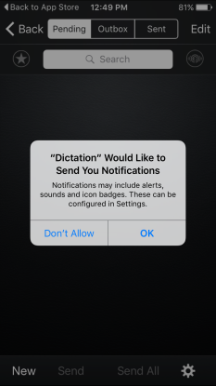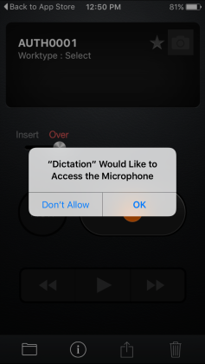

GENERAL: HOW TO USE A DICTATION APP

To record a dictation

(i) Press the Record button:
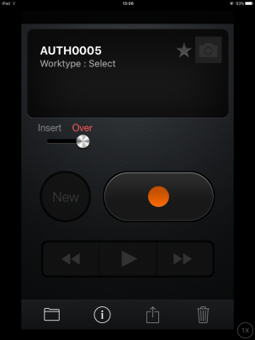

(ii) Dictate at a normal speaking volume.

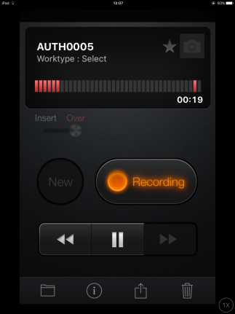

(iii) Use the Rewind and Play buttons to go back and make corrections or amendments:

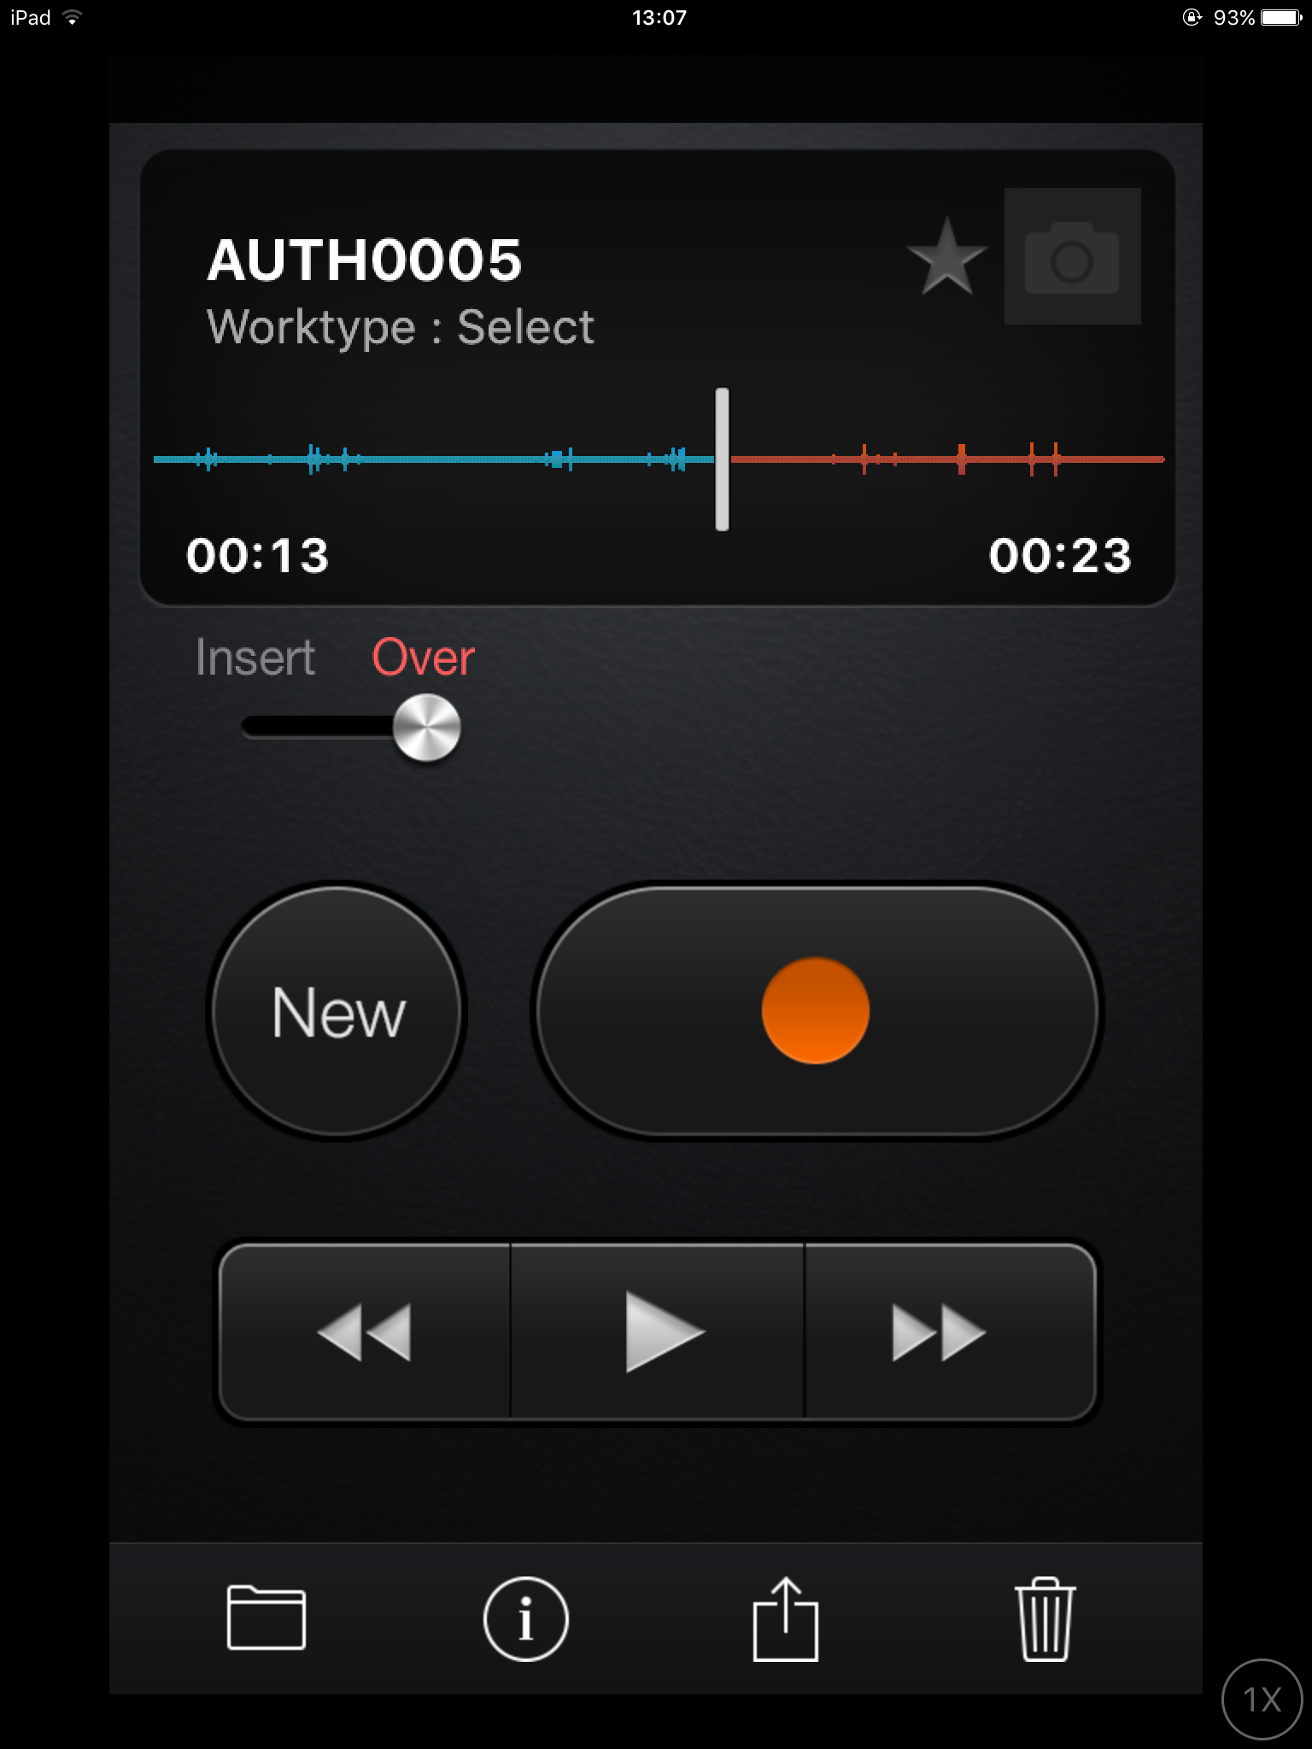

OR use the white slider to slide back
to the correct position.

(iv) With Over selected, as shown above, press Record again to re-record over the previous speech and then continue dictating.

(v) Alternatively move the button to Insert to insert text part way through existing dictation.

*** N.B. To limit the file size for emailing, each file should be a maximum of 30 minutes long.
After 30 minutes, stop recording and begin a New dictation file.***

To rename and save dictation files

(i) Click in the name and type in the new file name – format as yyyymmddFilename

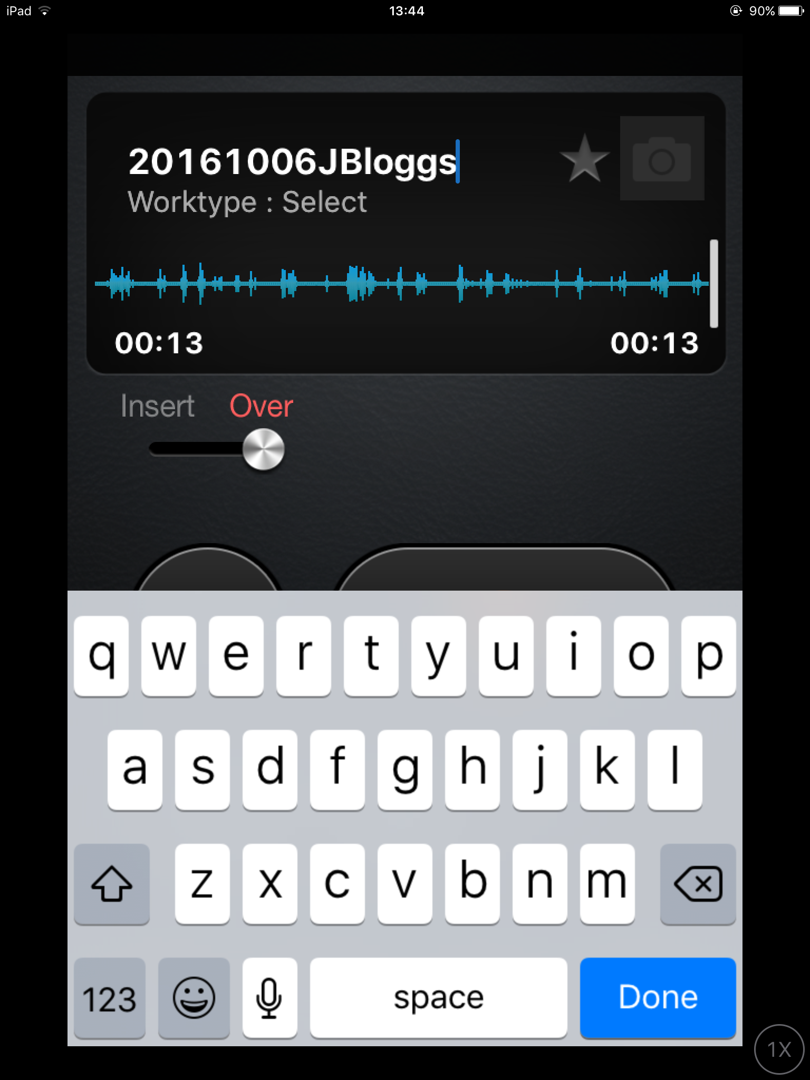
(ii) Press Done to save.

(iii) All files are automatically saved in the Pending folder, until they have been emailed when they automatically move through the Outbox to the Sent folder.

To edit previously saved files

(i) Choose the Folder button:

(ii) Choose the file to be changed, then click Edit:

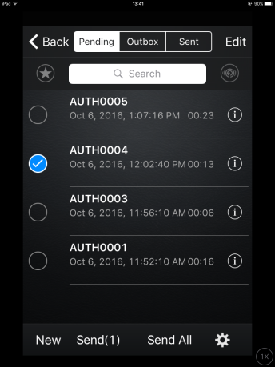

(iii) Press the orange Record button to continue recording in the same file.

(iv) Press Rewind and Play, and then press Record to edit or re-record a section.

HOW TO SEND DICTATION FILES FOR TRANSCRIPTION

(i) Choose the dictation to be sent as above.

(ii) Press on Send or the Send icon: .

(iii) Choose Send via Email:

(iv) Type in the required email address and any particular instructions in the email and press Send.
Members Services memsec@tynwald.org.im
Hansard handard@tynwald.org.im

